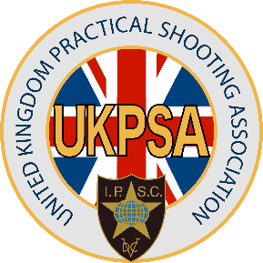  Registered Charity No. 277566 |  |  | United Kingdom  Practical Shooting Association  Email: janina.white@ukpsa.org  Tel: 0844 500 7520
Our ref: C-JT-21032024

John Thorn
By email only info@silverstoneshootingcentre.co.uk
Cc Clive Gamblin, Wendy Thomas
 |  |  | Date 24.06.2024

COMPLAINT

Dear Mr. Thorn,

I am writing to formally inform you that a complaint has been lodged against you by Mr. Andrews Williams (on behalf of the UKPSA Council), Mr Constantine Christophi, Mr. Paul Wyborn as well as Mr. Callum Long-Collins. The complaint details several allegations of misconduct and gross misconduct, specifically citing your recent actions on social media and other platforms. As part of our procedural requirements, we are providing you with an opportunity to present your version of events and respond to the allegations made against you.

Summary of Allegations:
- False Accusations (3/12/2023):
It is alleged that on December 3, 2023, you posted false accusations regarding the conduct of Mr. Long-Collins, Constantine Christophi, and Paul Wyborn on Facebook, sharing these accusations across multiple groups. This act may be considered a violation of UKPSA Byelaws, specifically Section 7.5, 6.a, 6.b, and 6.d.
- Damaging Video (2/1/2024):
On January 2, 2024, you allegedly posted a video on the Silverstone Shooting Centre YouTube channel and shared it across multiple Facebook pages and groups. In this video, you accused Mr. Long-Collins and the entirety of the UKPSA council of fraud, theft, and corruption without evidence. The UKPSA has refuted these accusations, stating that several points in the video are lies. This post may also be considered a violation of UKPSA Byelaws, specifically Section 7.5, 6.a, 6.b, and 6.d.
- Unauthorised Publication (12/1/2024):
On January 12, 2024, you allegedly published an internal UKPSA document on the Silverstone Shooting Centre Facebook page. This act may be in direct contravention of Section 7.7 of the UKPSA Byelaws.
Mr. Long-Collins claims that these actions have caused him significant emotional distress, adversely affecting his personal and professional life, and damaging his reputation and that of the association.

Request for Your Response:
In light of these allegations, we request that you provide your version of events and any evidence or statements in your defence. Please respond within 14 days of receiving this letter. Your response will be considered in any further actions or decisions taken by the association.
Additionally, the association may review whether your actions demonstrate the character, trustworthiness, and habits expected of a Firearms Certificate (FAC) holder and Registered Firearms Dealer (RFD). There may be an obligation to notify relevant authorities if any concerns are identified.
Please submit your response in writing to janina.white@ukpsa.org.
We appreciate your prompt attention to this matter.

Sincerely,

Janina White

Chair, Conduct and Standards Committee
UKPSA

